**MySQL Example Using MySQL on Docker**

**Ques-)** Create a table world having attribute (name, continent, area, population,gdp).

Write a SQL solution to output big countries' name, population and area.

**Note:** A country is big if it has an area of bigger than 3 million square km or a population of more than 25 million.

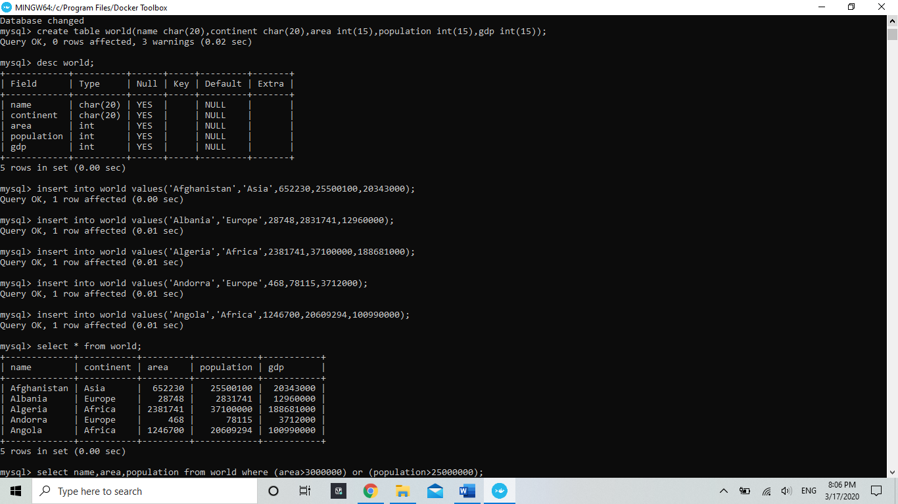**Solution:**

As we have created our table according to the question. So here we will perform our main task.

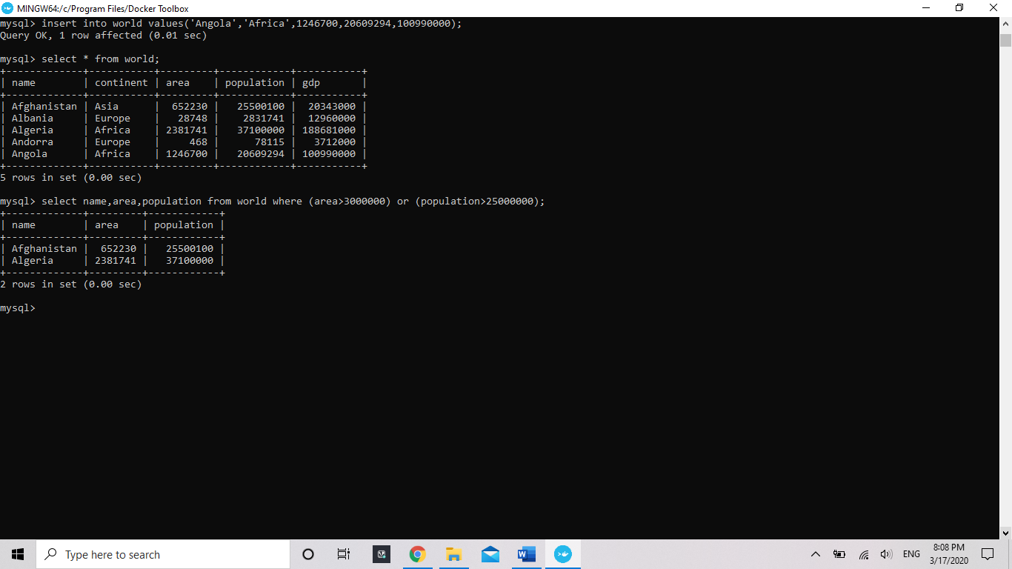So that’s all for now we have performed our given task.